# 

# 

# 

# Experiment #9: Transfer Functions

Christopher Badolato

Yajaira Varillas Perez

EEL3123C-0013

3/27/2019

## 

## 

## 

## 

## 

## 

## Objectives

* To study the transfer function of a circuit.
* To use the transfer function to find the specified frequency specified in the different cases.

## Equipment

* Breadboard
* Function generator
* Oscilloscope
* Digital multimeter (DMM)

Circuits (taken directly from lab manual)

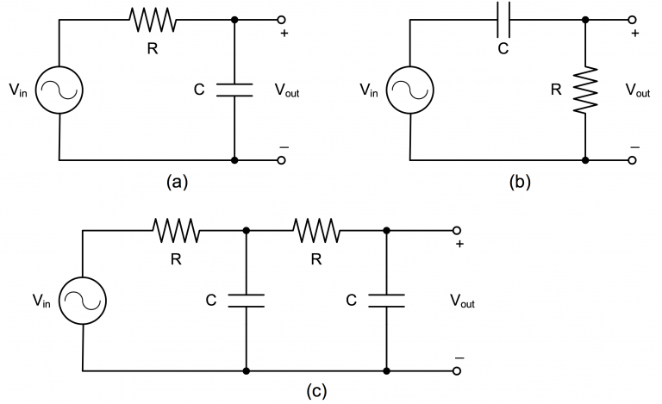

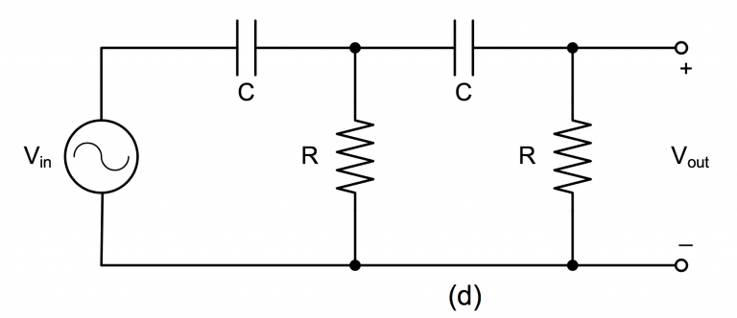

Simulations

|  |
| --- |
| We will be looking at the frequency response plots of each circuit or the Transfer function  For each of the circuits below, we used inputs into function generator:  Calculated frequency from prelab  1591.55 Hz or 1.592kHz $±$ 5V  These values match the values calculated in the prelab |

|  |
| --- |
| **Circuit A**  Frequency = 1.6145kHz  Phase difference = -45.3582°  Phase difference between the two outputs and frequency where amplitude of output voltage is $\frac{1}{\sqrt{2}}$ the input voltage. |

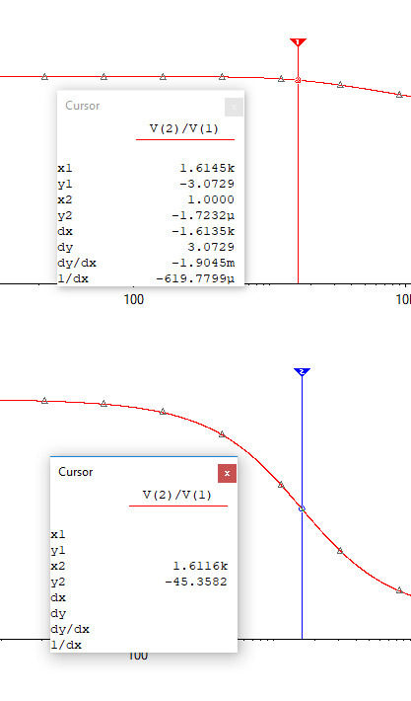

|  |
| --- |
| **Circuit B**  Frequency = 1.5925kHz  Phase difference = 44.9825°  Phase difference between the two outputs and frequency where amplitude of output voltage is $\frac{1}{\sqrt{2}}$ the input voltage. |

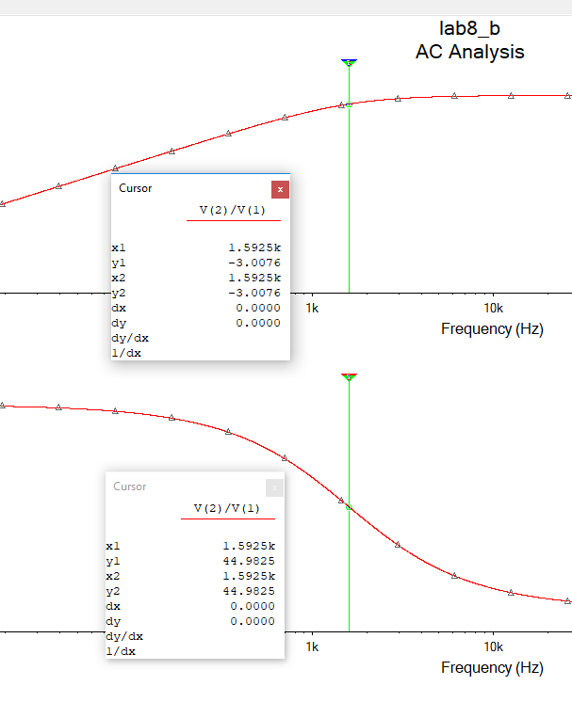

|  |
| --- |
| **Circuit C**  Frequency = 1.6145kHz  Phase difference = -90.29982°  Phase difference between the two outputs and frequency where amplitude of output voltage is $\frac{1}{3}$ the input voltage |

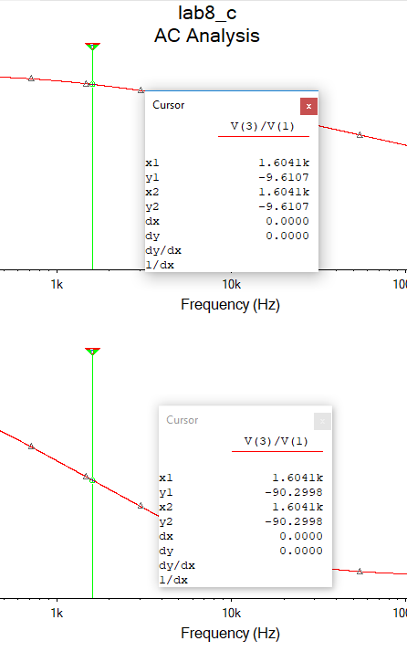

|  |
| --- |
| **Circuit D**  Frequency = 1.6041kHz  Phase difference = 89.7002°  Phase difference between the two outputs and frequency where amplitude of output voltage is $\frac{1}{3}$ the input voltage. |

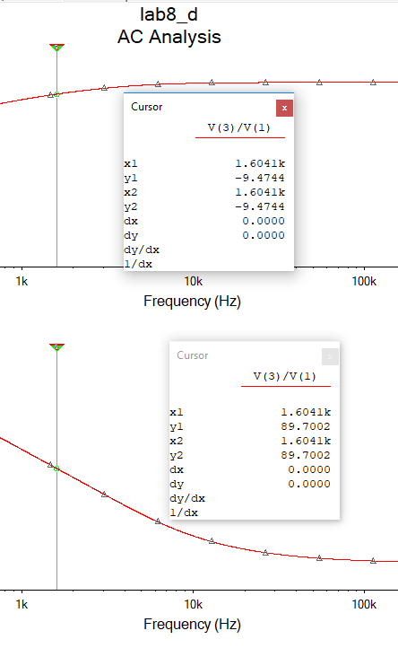

Experiment

|  |
| --- |
| The transfer function is defined as the ratio of the output response to an input excitation. $H(s) = \frac{Output (s)}{Input (s)}$ For each circuit below we using the same input values and the simulations.  1591.55 Hz or 1.592kHz $±$ 5V  We will observe the phase difference between output with one oscilloscope measuring the input voltage, and one measuring the output voltage. We fluctuate the frequency depending on the location of our phase angle.  For the experiment our frequencies differed slightly from the preparation and simulated values.  They are only off at most by a few hundred hertz.  To measure our phase difference (without just using the phase button on the oscilloscope) we can first, measure the time difference between the two peaks of Vin and Vout. Then we can apply the formulas below to find phi. |

|  |
| --- |
| Circuit A  Frequency = 1.56kHz  Phase Difference = -45.43°  Phase difference between the two outputs and frequency where amplitude of output voltage is $\frac{1}{\sqrt{2}}$ the input voltage. |

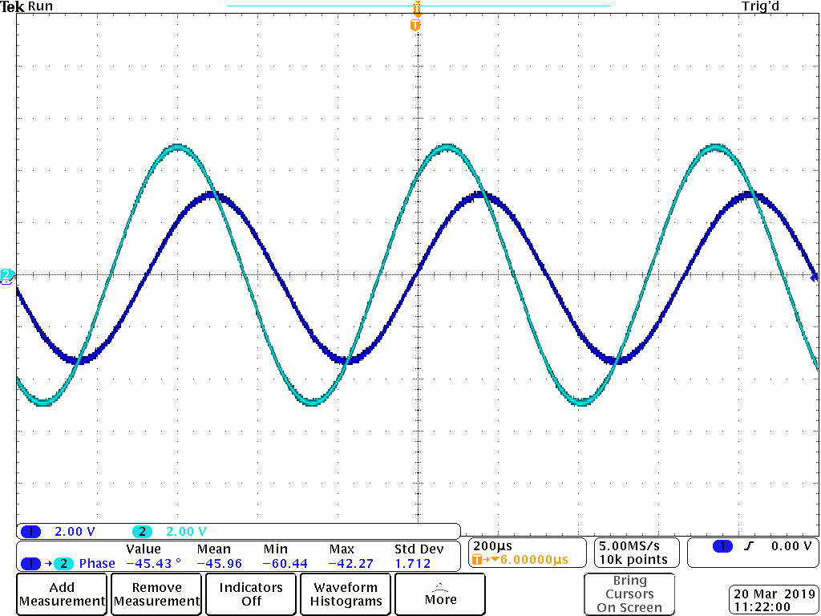

|  |
| --- |
| Circuit B  Frequency = 1.37kHz  Phase difference = 45.02°  Phase difference between the two outputs and frequency where amplitude of output voltage is $\frac{1}{\sqrt{2}}$ the input voltage. |

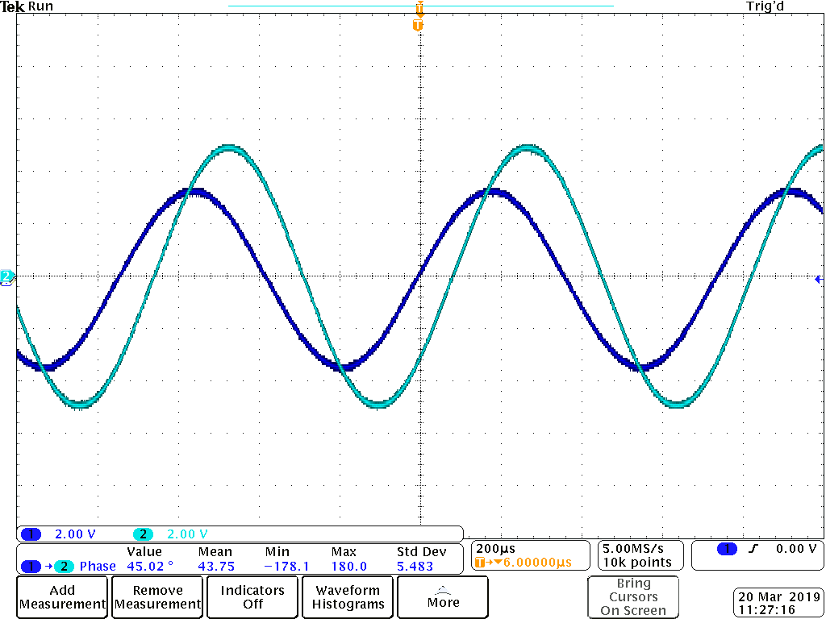

|  |
| --- |
| Circuit C  Frequency = 1.53kHz  Phase difference = -90.28°  Phase difference between the two outputs and frequency where amplitude of output voltage is $\frac{1}{3}$ the input voltage |

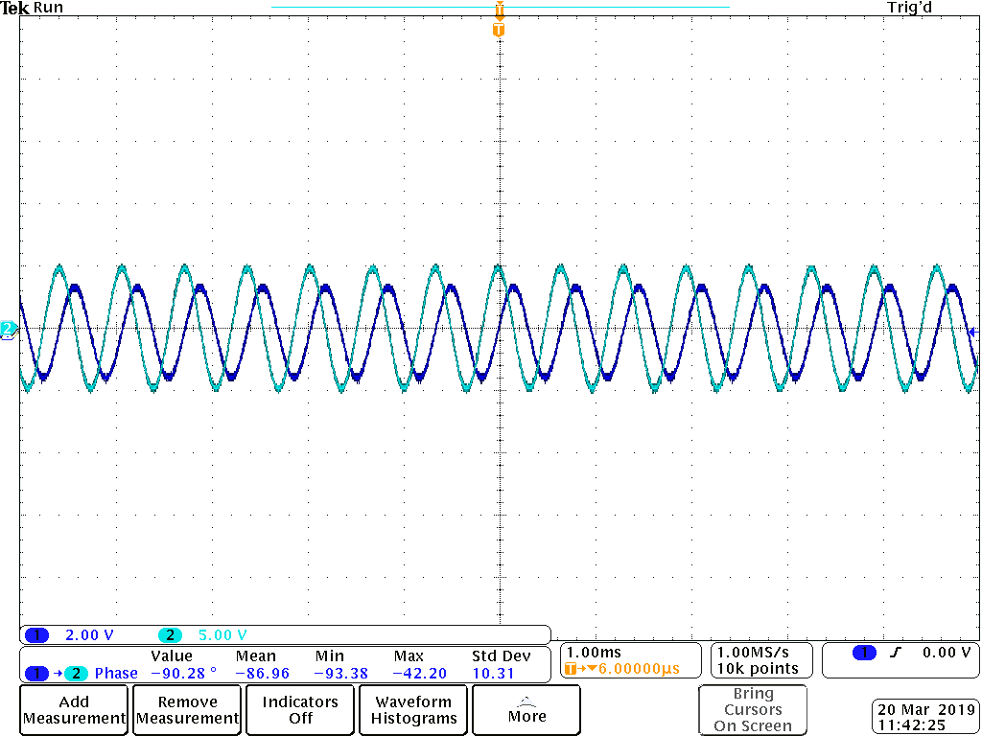

|  |
| --- |
| Circuit D  Frequency = 1.41kHz  Phase difference = 87.26°  Phase difference between the two outputs and frequency where amplitude of output voltage is $\frac{1}{3}$ the input voltage. |

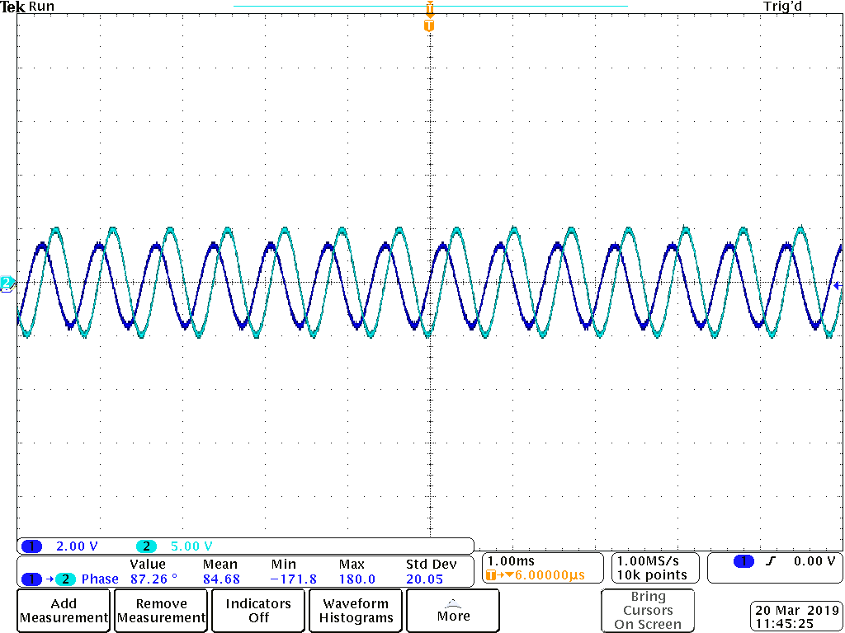

Conclusion

The transfer function of a circuit is defined as the ratio of the output response to the input excitation. The transfer function is a complex value with a phase and a magnitude that are functions of the response to the frequency. In this experiment, we calculated the transfer function of each of the circuits. We can use the information we found to measure output voltage at the same frequency as the phase angle.